

Project Interim Report

On

Digital Wallet Payment System (OOP Project) RU-100-01-00012
Object Oriented Programming with Java

SESSION: 2025-26

Submitted By
Anmol Dubey
RU-25-11812

Bachelor of Technology in Computer Science & Engineering (Cyber Security) in Association with EC Council

Under the Guidance of Mr. Ashish Shivhare

SCHOOL OF COMPUTER SCIENCE AND ENGINEERING RUNGTA INTERNATIONAL SKILLS UNIVERSITY
BHILAI, CG

(April 2026)

Abstract
The Digital Wallet Payment System is a robust Java-based application designed to simulate secure financial transactions using core Object-Oriented Programming (OOP) principles. In today's digital economy, electronic wallets are essential for providing users with a seamless and secure platform for managing their funds. This project is needed to demonstrate how backend systems protect sensitive financial data while executing core banking logic. The system allows users to securely store their balances, make direct deposits, and execute wallet-to-wallet fund transfers. It uniquely features a global cashback policy that automatically rewards users during transfers. By prioritizing data encapsulation and runtime error management, the project ensures that transactions are processed safely, mirroring the reliability required in real-world fintech applications.

Introduction
The transition to cashless economies has made digital wallets an everyday necessity. This project focuses on building the foundational logic of a Digital Wallet Payment System using Java. It emphasizes strict data security and transaction integrity over visual interfaces.
Key features of this system include:
- Secure Balance Management: Prevents unauthorized access or direct modification of funds.
- Wallet-to-Wallet Transfers: Simulates real-time peer-to-peer payments.
- Automated Rewards: Implements a global 2% cashback system for all valid outgoing transfers.
- Fail-Safe Transactions: Automatically halts operations if user inputs are invalid (e.g., negative amounts) or if funds are insufficient, preventing data corruption.

Objectives
- To securely manage user wallet balances using private fields.
- To facilitate and track money transfers between different wallet entities.
- To implement a centralized, universally shared cashback rate.
- To prevent system crashes during invalid transactions using exception handling.
- To practically apply OOP concepts (Encapsulation, Static Members, Exception Handling) in a financial context.

Scope
This project currently focuses on core back-end transaction logic and is highly suitable for conceptual demonstrations, small library simulations, or academic evaluation. In the future, the scope can be easily extended to include database integration for persistent data storage, a graphical user interface (GUI), and transaction histories.

System Requirements

- Hardware: Computer/Laptop with a minimum of 4GB RAM.
- Software: Java Development Kit (JDK) 8 or higher, and a standard IDE (e.g., VS Code, Eclipse, IntelliJ IDEA).

Methodology

The system operates on a sequential object-oriented flow:

- Initialization: The system creates unique Wallet objects for different users. The global cashback rate is preset in the system memory.
- Funding: Users add money to their wallets using a deposit mechanism that only accepts positive values.
- Transaction Request: A sender initiates a transfer by specifying the recipient's wallet and the transfer amount.
- Validation (Try-Catch): The system checks if the amount is greater than zero and if the sender has sufficient funds.
- Execution & Reward: If valid, the amount is deducted from the sender and added to the receiver. The system calculates the cashback and instantly credits it back to the sender's balance.
- Confirmation: The system prints the updated balances and transaction status.

Flowchart

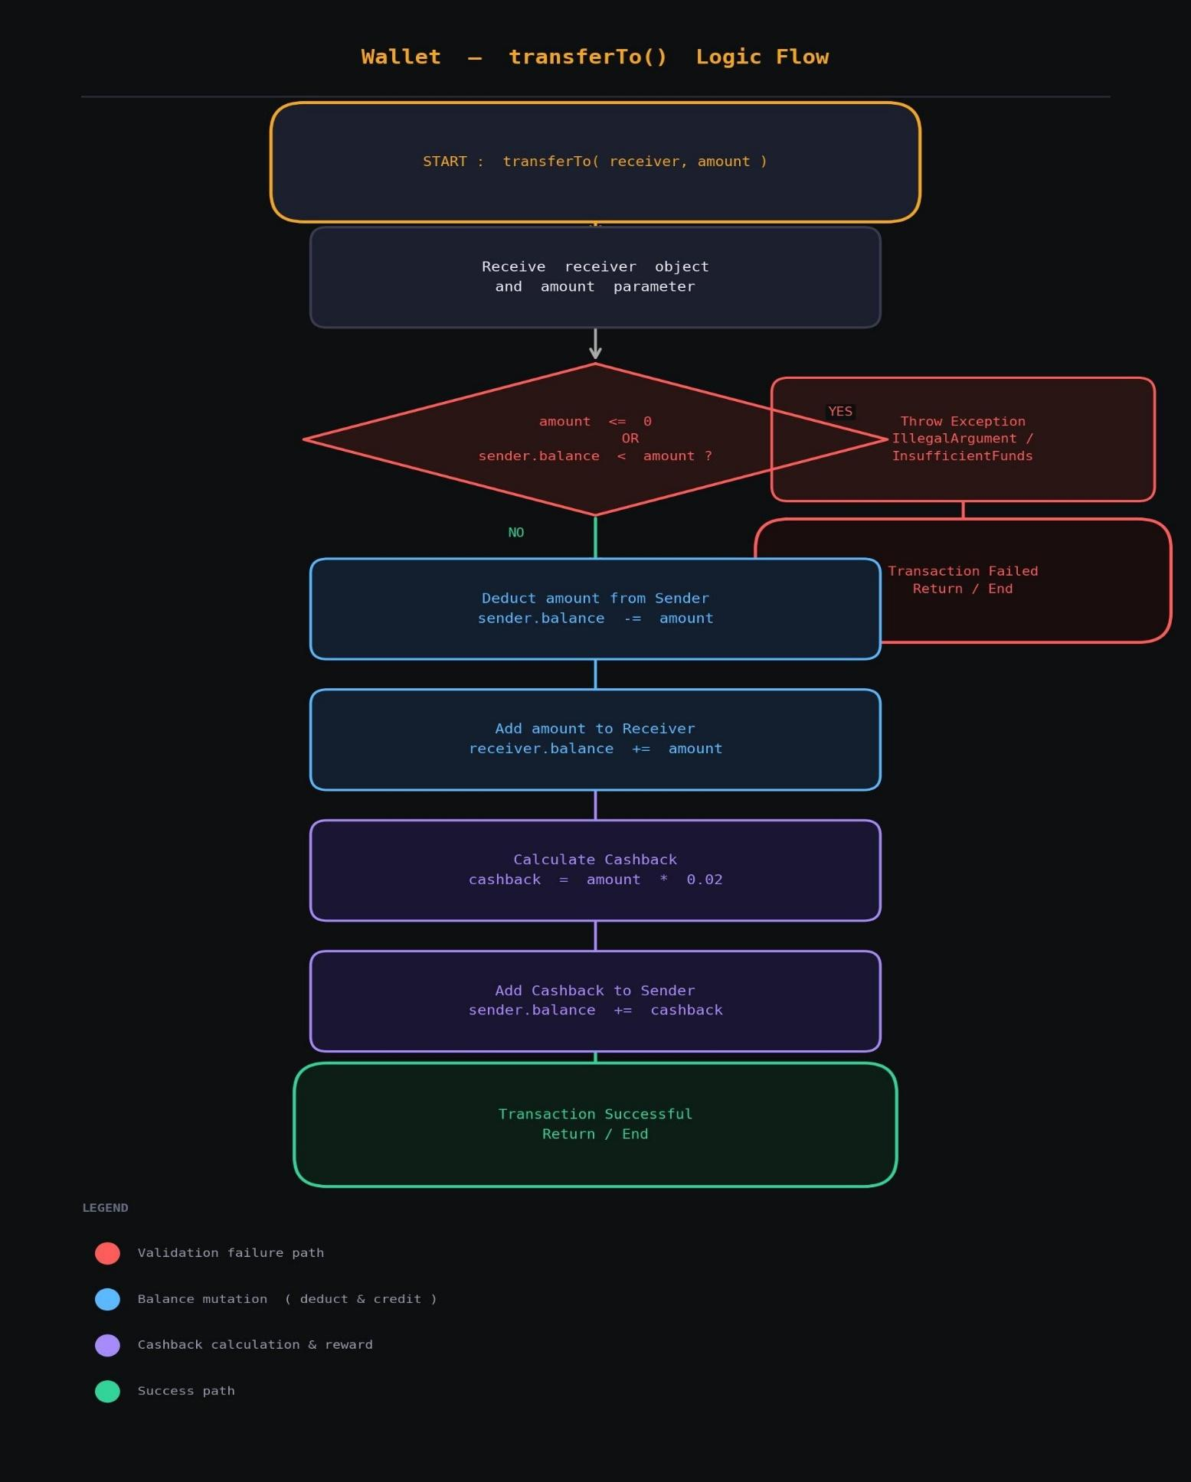

Class Diagram

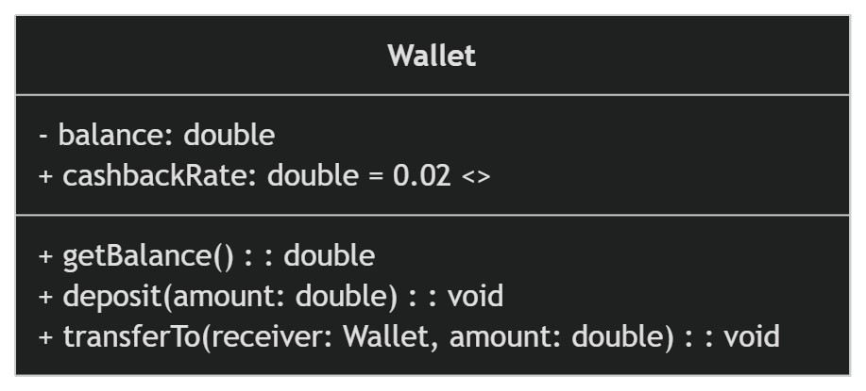

Implementation

The logic of the system is primarily housed within a single, highly cohesive Wallet class:

- Data Hiding (Encapsulation): The balance is deliberately kept private. The logic dictates that external classes cannot directly change the balance; they must use the deposit or transferTo methods. A public getter provides read-only access.

- Shared Configuration (Static Keyword): The cashback rate is defined as a static variable. The logic here is that the policy applies universally to all wallets. Changing this single static variable would instantly update the reward rate for every wallet in the system without needing to modify individual objects.

- Safe State Transitions (Exception Handling): The transferTo method contains the core business logic wrapped in a try block. It uses throw new Exception to generate errors for negative inputs or insufficient funds. The catch block captures these errors and prints a user-friendly failure message, ensuring the program continues running rather than crashing.

Gantt Chart

Day 1: System Design & Class Diagram mapping.

Day 2: Setting up the Wallet class, private fields, and basic methods (deposit, getBalance).

Day 3: Implementing the complex transferTo logic, static cashback, and exception handling.

Day 4: Testing edge cases (negative amounts, zero balance) and debugging.

Day 5: Drafting the project report, formatting, and preparing for the Viva presentation.

Conclusion
This project successfully demonstrates the power and necessity of Java OOP concepts in building reliable software. By utilizing encapsulation, the system ensures that sensitive financial data remains secure. The implementation of static variables showcases efficient memory management for shared configurations, while robust exception handling guarantees that the system can gracefully manage errors without compromising user data or program stability. It provides a highly functional foundation for a modern financial application.

References

[1] H. Schildt, Java: The Complete Reference, 12th ed. New York: McGraw-Hill, 2021.

[2] Oracle, "Java Tutorials: Exceptions," Oracle. [Online]. Available: https://docs.oracle.com/javase/tutorial/essential/exceptions/

[3] Oracle, "Understanding Class Members (Static Fields)," Oracle. [Online]. Available: https://docs.oracle.com/javase/tutorial/java/javaOO/classvars.html

